INTERNATIONAL ORGANISATION FOR STANDARDISATION
ORGANISATION INTERNATIONALE DE NORMALISATION
ISO/IEC JTC 1/SC 29/WG 11
CODING OF MOVING PICTURES AND AUDIO

ISO/IEC JTC 1/SC 29/WG 11 N13868
Vienna, AT – July 2013

Source: | Communication sub-group
Title: | White Paper on the MPEG Query Format: Standardizing Access to Multimedia Retrieval Systems

Contents
Abstract 3
1 Introduction 3
2 Scope and Objectives 3
3 Application 4
4 Technology 5
4.1 MPEG Query Format Data Model 5
4.2 Distributed Multimedia Retrieval Scenarios 6
4.3 Input Query Format 7
4.4 Output Query Format 10
4.5 MPQF Examples 12
5 Related Developments 14
6 References 15

The MPEG Query Format:
Standardizing Access to Multimedia Retrieval Systems
Ruben Tous, Jaime Delgado

Abstract
The MPEG Query Format is an ISO/IEC standard, now in its second edition (ISO/IEC 15938-12:2012), that has been developed under the auspices of the Moving Picture Experts Group (MPEG). The MPEG Query Format, also known as MPQF, facilitates a standard multimedia query language so that service providers can offer users and applications a unified interface for querying media repositories. The query format provides three different sets of tools, which are input query format, output query format, and query management. The input query format specifies the interface through which the users can describe their search criteria with a set of precise input parameters in addition to a set of preferred output parameters to depict the return result sets. The output query format specifies the interface format for the result set. The query management provides means for selecting services or aggregated services based on service properties (e.g. supported query format).

Introduction
The increased availability and usage of digital images has highlighted the need for efficient multimedia data storage and retrieval solutions. Currently, there are numerous storage and retrieval approaches ranging from commercial products to the purely academic. The diversity of these individual projects prevents users from experiencing broad and unified access to different multimedia collections. In fact, almost every solution provides a different retrieval interface and is based on different multimedia metadata description formats. The varied query approaches along with the alternate metadata description formats and retrieval interfaces prevents effective interoperability among current multimedia retrieval systems. In this context, ISO/IEC JTC1/SC29 WG11 (more commonly known as MPEG) established the MPEG Query Format (MPQF) [1, 2, 3, 4, 5, and 6] standardization to create a standard interface for media repositories. The MPEG Query Format, also known as MPQF, facilitates a standard multimedia query language so that service providers can offer users and applications a unified interface for querying media repositories.

Scope and Objectives
The general goal of MPQF is to provide a standard multimedia query language to unify access to distributed multimedia retrieval systems. To achieve this goal, the MPQF standard specifies precise input and output parameters to express multimedia requests and to allow clients easy interpretation and processing of result sets. Moreover, the management component of the MPQF covers searching and the choice of the desired multimedia services for retrieval. For this purpose, the standard provides a means to describe service capabilities and to undertake service discovery. It is also important to note that while the MPQF is part 12 of the MPEG-7 standard, the specification explicitly allows for deployments using any XML-based multimedia metadata description format.

One of the key features of MPQF is that it allows the expression of multimedia queries combining both the expressive style of information and XML Data Retrieval systems. Thus, MPQF combines e.g. keywords and query-by-example with e.g. XQuery allowing the fulfillment of a broad range of users' multimedia information requirements. Both approaches to data retrieval aim to facilitate clients' access to information, but from different points-of-view. On one hand, given a query expressed in a user-oriented manner (e.g. an image of a bird with blue wing tips), an Information Retrieval system aims to retrieve information that might be relevant even though the query is not formalized. In contrast, a Data Retrieval system (e.g. an XQuery-based database) deals with a well-defined data model and aims to determine which objects of the collection satisfy clearly defined conditions in a relational algebra expression (e.g. the title of a movie, the size of a video file or the fundamental frequency of an audio signal). For a data retrieval system, like a relational database or an XML repository, a single erroneous object among thousands retrieved means a total failure. In contrast, an information retrieval system can supply results that appear relevant and expect a user to 'filter' those results further.

With regard to the task of Information Retrieval, MPQF offers a broad range of possibilities that include but are not limited to query-by-example-media, query-by-example-description, query-by-keywords, query-by-feature-range, query-by-spatial-relationships, query-by-temporal-relationships and query-by-relevance-feedback. For Data Retrieval, MPQF offers its own XML query algebra for expressing conditions over the multimedia related XML metadata (e.g. MPEG-7, Dublin Core or any other XML-based metadata format) but also offers the possibility to embed XQuery expressions.

It is worth mentioning that, in 2012, MPEG released a second edition of MPQF (ISO/IEC 15938-12:2012) that cancels and replaces the first one (ISO/IEC 15938-12:2008), which has been technically revised. The second edition also incorporates all the previous amendments and corrigenda, i.e. ISO/IEC 15938-12:2008/Cor.1:2009, ISO/IEC 15938-12:2008/Cor.2:2010, ISO/IEC 15938-12:2008:Amd.1:2011 and ISO/IEC 15938-12:2008:Amd.2:2011.

Application
Services and products that may benefit of a unified and powerful interface for querying media repositories include, but are not limited to: Multimedia database management systems, online photo-sharing, video-sharing and social networking services, audio and video on demand systems (AVOD), digital asset management systems (DAMS), video surveillance systems and digital libraries. The two main benefits of standardization of such a language are 1) interoperability between parties in a distributed scenario (e.g. content providers, aggregators and clients) and 2) platform independence (which also offers benefits for non-distributed scenarios). The result is that developers can construct applications exploiting multimedia queries independent of the multimedia service used; this fosters software reusability and maintainability. As a technical specification from MPEG, this initiative is an international, open standard targeting all application domains.

Technology
MPQF instances are XML documents that can be validated against the MPQF XML Schema. An MPQF instance always includes the MpegQuery element as the root element and beneath that the Query element or the Management element (see Figure 1). MPQF instances with the Query element are the usual requests and responses of a multimedia search process. The Query element can include the Input element or the Output element, dependent on whether the document is a request or a response. The contents of the Input element are referred to as the Input Query Format (IQF) in the MPQF standard while the Output element is named the Output Query Format (OQF). A special query input constitutes the FetchResult element which is used in asynchronous mode for collection search results. Alternatively, below the root element, an MPQF document can include the Management element. Management messages (which can be both requests and responses) provide a means for requesting service-level functionalities such as discovery of multimedia services or other kinds of service provision, interrogating the capabilities of a service, or configuring service parameters.

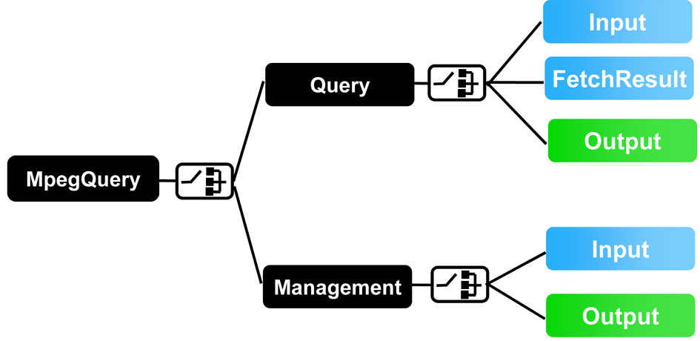
Figure 1. Schema overview of the uppermost elements of the MPEG Query Format

MPEG Query Format Data Model
An MPQF query is expressed in terms of a certain information representation space. The MPQF Data Model formally defines this information representation space and constitutes the basis of an MPQF query processor and optimizer. When writing an MPQF query, one must consider that it will be evaluated against one or more multimedia services and, from the point-of-view of MPQF, a multimedia service is an unordered set of Multimedia Content (MC), containing e.g. a reference to audiovisual data or text documents. The concept of Multimedia Content (MC) refers to the combination of multimedia data and its associated metadata (see Figure 2). MPQF allows search and retrieval of complete or partial MC data and metadata by specification of a filter condition tree and desired processing granularity. Conditions within that tree operate on one evaluation-item (EI) at a given time, or two EIs if a Join operation is used. By default, an evaluation-item (EI) is a multimedia content in the multimedia service, but other types of EIs are also possible. For instance, an EI can be a segment of a multimedia resource, or an XPath item related to the MC’s metadata XML tree, as it is defined in the XQuery 1.0 and XPath 2.0 Data Model (XDM) [10]. As mentioned previously, MPQF allows search and retrieval of both complete and partial MC. The scope of query evaluation and the granularity of the result set can be determined by a EvaluationPath element specified within the query. If this EvaluationPath element is not specified, the output result is provided as a collection of multimedia content, as stored in the repository, all satisfying the query condition.

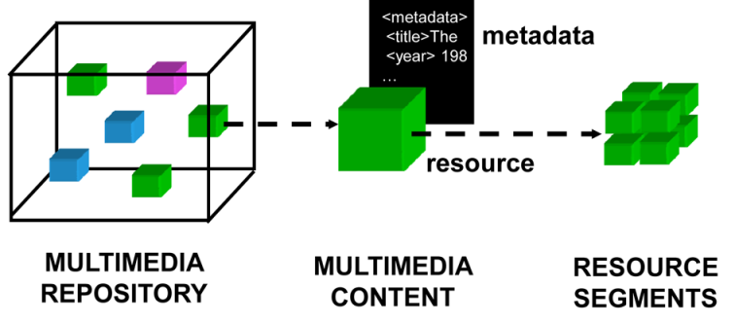
Figure 2. MPQF Data Model. A multimedia repository and a Multimedia

Distributed Multimedia Retrieval Scenarios
MPQF defines a request-reply XML-based interface between a requester and a responder. In the simplest scenario, the requester may be a client and the responder might be a multimedia retrieval system. However, MPQF has been specially designed for more complex scenarios, in which clients interact, for instance, with a content aggregator. The content aggregator acts at the same time as both a responder (from the point-of-view of the client) and requester to a number of underlying content providers to which the client query is forwarded. Figure 3 depicts a possible setup for the use of the MPEG Query Format. Besides the benefit that any MPQF aware client is able to interact in a standardized way with any MPQF service, the management part also supports the discovery of multimedia services in a highly distributed and heterogeneous environment.

For this purpose, the management part of the standard explicitly foresees service discovery functionality which may result in registry applications such as the naming service of CORBA or the UDDI service in the service oriented architecture of Web Services. Such a registry service allows the registration (by sending their service capability description) of distributed multimedia services and thus makes them available to a broader community; in consequence, the retrieval system of the service provider becomes much more valuable. Note, that the standard only specifies how a client can interact with such a registry application; the actual process of registration and its implementation are out of scope of the MPQF standard.

Another aspect of a distributed retrieval scenario is the communication paradigm employed and whether it is synchronous or asynchronous. Whereas the synchronous mode satisfies most common multimedia retrieval scenarios it is insufficient when the search operation requires a long processing time or the display capability of the client’s device is inadequate (e.g., mobile phone, etc.) for presenting the results. For such environments, the MPQF standard supports a means for signaling to the multimedia service the desire for asynchronous operation. In that case, the service responds with a query ID and time span information which allows the client to fetch the result from a different place at a later time point (and/or on a different device).

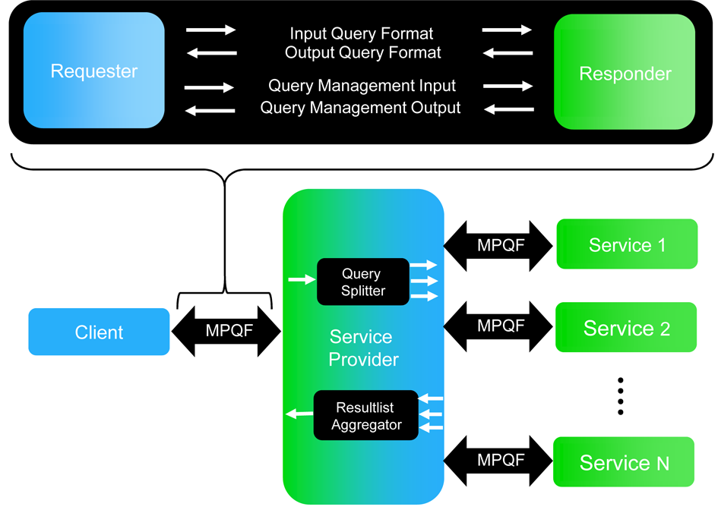
Figure 3. Possible scenario for the use of the MPEG Query Format

Input Query Format
The part of MPQF describing the contents of the Input element is named the Input Query Format (IQF, see Figure 4). The IQF defines the syntax of messages sent by the client to the multimedia service, which specify the client’s search criteria. The two main components of the IQF allow specification of a filter condition tree (by using the QueryCondition element) and definition of the structure and desired content of the service output (by the OutputDescription element) respectively. The IQF also allows declaration of reusable resource definitions and metadata paths (fields) within the QFDeclaration element, and the set of services where the query should be evaluated (the ServiceSelection element) in the case of communication with an aggregation service.

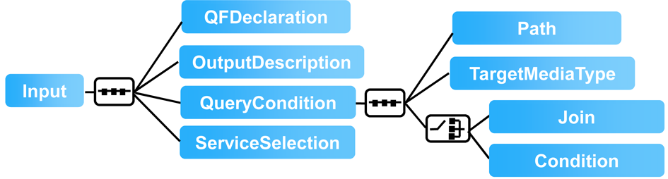
Figure 4. Input Query Format (IQF)

QFDeclaration: The optional QFDeclaration element allows declaration of reusable definitions of data paths and resources that can be referenced multiple times within a query. A data path is declared by a DeclaredField element which contains a relative or absolute XPath expression pointing to an item of the service’s metadata. A Resource element operates as container for one of the following components:
- MediaResource describes a resource by containing or pointing to the raw multimedia material.
- DescriptionResource specifies the container for any description based on a specific schema specified by the namespace declaration within the description. By introducing the QFDeclaration element, the size of the query can be significantly smaller, if the same elements appear multiple times in one query.

Output Description: The OutputDescription element describes the structure and content of the individual result items within the result set. Furthermore, it allows (by two optional attributes) the definition of an overall item count and the maximum number of items per output page. The occurrence of the second attribute indicates that paging of the result set is desired. In the following, the main features of the OutputDescription element are introduced:
- ReqField describes the data path to the element, which a client asks to be returned. Paths are either specified using absolute XPath expressions, which refer to the root of the description or by using relative XPath expressions referring to a given schema’s complex type.
- ReqAggregateID describes the unique identifier of the aggregate operation the client asks to be returned. When one or more ReqAggregateIDs are used, the aggregate ID should be grouped.
- GroupBy describes the grouping operation the user wants to apply on the result set. For this purpose, the GroupBy element allows the specification of several GroupByField elements, which describes the key for the grouping process and according aggregation operations. The GroupByField element contains an absolute or relative XPath expression pointing to an item at the service’s metadata. In a usual case, leaf nodes are intended to be used as an instance of the GroupByField. When a structured field (e.g. a MPEG-7 Description Scheme type) is defined as a key, all the mandatory elements and attributes included in the pointed node must be considered for grouping. Optional fields should be specified individually in order to be considered in the grouping process.
- SortBy describes the sort operation the client wants to apply on a result set. The result set can be sorted in increasing or decreasing order according to a given Field element or an aggregate expression. The Field element contains an absolute or relative XPath expression.

Query Condition: The query condition supports a client expressing filter criteria for retrieval. The main entry point for formulating filter criteria is the QueryCondition element (see Figure 4) which features an optional Path element, an unbounded number of TargetMediaType elements and a choice between a Join and a Condition element. The Path (a XPath expression) element specifies the granularity of the retrieval and therefore the node of the metadata fragment related to the evaluation item. For instance, in the case of MPEG-7, the Path //Video would focus the retrieval to whole video objects whereas the Path //VideoSegment would lead to the more specific video segment objects. The TargetMediaType element contains MIME type descriptions of media formats that are the targets for retrieval. For instance, the MIME type audio/mp3 would filter all results for audio files depending on the MP3 format. Further, diversity in filter criteria is provided by the Condition element. The Condition element is a placeholder for a boolean expression type (see Figure 5 for its type hierarchy) and may result in an n-ary filter tree. As outlined in Figure 5, the filter tree can be established by three main constructs, namely query types, comparison expressions and boolean operators. In general, instances of query types always represent leaf nodes within the filter tree. Nodes of type comparison expression can occur as inner nodes and leaf nodes and finally, nodes that represent boolean operators are always inner nodes. In order to indicate the importance of individual parts during the retrieval process, one can assign a preference value to every boolean expression element, and hence to each node within the filter tree.

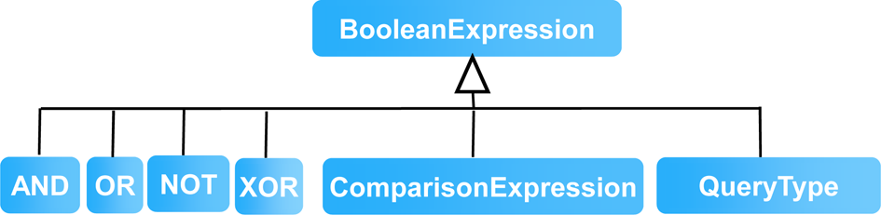
Figure 5. Boolean Expression Hierarchy

Comparison Expression: In MPQF, a comparison expression is defined as common by the following term: A op B, where A,B belong to OperandClass and op belongs to {<, >,= , ≥, ≤, ! =, stringContainment}. An OperandClass denotes a representation of a specific data type, such as Boolean, String, Arithmetic, DateTime or Duration. Note, that both operands (A, B) must belong to the same OperandClass within a comparison expression. Every element of an OperandClass can be described by (1) a value of the data type, (2) a XPath expression pointing to a value of the specific data type or (3) a corresponding expression (e.g., String expression, Arithmetic expression, etc.) resulting to a value of the specific data type. String, Arithmetic and Boolean expressions are similarly defined as comparison expressions but restrict their operands A, B to the corresponding data type (e.g., String operands for String expression, Arithmetic operands for Arithmetic expressions, etc.).

<Condition xsi:type="Equal" >
<ArithmeticExpression xsi:type="Modulus">
<ArithmeticField typeName="AudioLLDVectorType">
/SeriesOfVector[@totalNumOfSamples]
</ArithmeticField>
<LongValue>2</LongValue>
</ArithmeticExpression>
<LongValue>0</LongValue>
</Condition>
Code 1. Example Arithmetic expression example

The short example (see Code 1) demonstrates the use of a comparison and arithmetic expression for MPEG-7 documents. By reverting to the previous term definition: A op B, then the example instantiates for op an Equal comparison operation, for the operand A an arithmetic expression and for B an arithmetic value (value 0). In series, the arithmetic expression is composed of the operation (op) Modulus, the operand A is a relative XPath expression pointing to an arithmetic value (totalNumOfSamples attribute of the AudioLLDVectorType type) and operand B again is an arithmetic value (value 2). During an evaluation process, this filter condition would result in documents that have an even number in the totalNumOfSamples attribute of the AudioLLDVectorType type.

Query Types: The current MPQF standard provides the following set of query types:
- QueryByMedia specifies a similarity or exact-match query by example retrieval where the example media can be an image, video, audio or text.
- QueryByDescription specifies a similarity or exact-match query by example retrieval where the example media
- is presented by any XML based multimedia description format (e.g., MPEG-7).
- QueryByFreeText specifies a free text retrieval where optionally the focused or to be ignored fields can be declared.
- QueryByFeatureRange specifies a range retrieval for e.g., low level features like color.
- SpatialQuery specifies the retrieval of spatial elements within media objects (e.g., a tree in an image) which may be connected by a specific spatial relation.
- TemporalQuery specifies the retrieval of temporal elements within media objects (e.g., a scene in a video) which may be connected by a specific temporal relation.
- QueryByXQuery specifies a container for limited XQuery expressions.
- QueryByRelevanceFeedback specifies a retrieval that takes into consideration result items of a previous search as bad and/or good examples.

Output Query Format
The Output Query Format (OQF) deals with the specification of a standardized format for multimedia query responses (see Output element in Figure 1). The two main components cover paging functionality (see subsection III-B1) and the definition of individual result items (see subsection III-B2). Besides, the OQF provides means for communicating global comments (by the GlobalComment element) and status or error information (by the SystemMessage element). Using a global comment, the responder can send general messages such as, the service subscription expiration notice or a message from a sponsor which is valid for the whole result set. When a proper result set cannot be composed, or when a special message regarding the system behavior should be communicated with the client, the multimedia service can use the SystemMessage element. This element provides three different levels for signaling problems, namely Status, Warning, and Exception. The codes and descriptions for the individual elements are defined in annex A of the standard specification. Finally, the validity period of a result set is indicated by the expirationDate attribute.

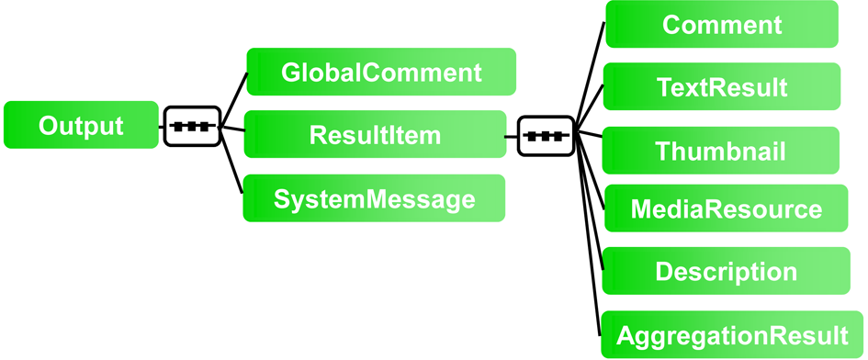
Figure 6. Schema Diagram of Output Query Format

Paging functionality: A client’s desire to retrieve a result set divided into individual pages is expressed by the use of the maxPageEntries attribute at the input query. If this flag is set, the multimedia service is responsible for dividing the complete result set into a series of individual MPQF instance documents. For this purpose, the OQF provides two attributes, namely currPage and totalPages to identify the individual pages. The currPage and totalPages attributes signal the total number of pages in the query result and the current page, respectively. For example, a value of two for currPage and ten for totalPages indicates that the second page of the query result is being transmitted and that a total of ten pages of the query result is available.

Individual Result Items: The ResultItem element of the OQF holds a single record of a query result. In the MPQF schema, the element is based on an abstract type which is targeted at future extensibility and allows more concrete instantiations. Figure 6 illustrates the standardized version of such an extension. The ResultItem has four attributes and six elements. The four attributes are recordNumber, rank, confidence, and originID. The recordNumber is a positive integer and the only required attribute. The recordNumber ensures the distinct identification of each record amongst the set of records returned for the given query. It can also be used in relevance feedback retrieval to refer to the relevance records. The rank is an optional attribute to indicate the relative similarity of the record to the submitted query. The confidence is an optional attribute to demonstrate the subjective correctness of the query result. The originID is also an optional attribute to indicate from which URI the specific record came from. For example, when there are multiple service providers involved with answering a given query, the originID can be used to identify the service provider from which the result item is received. In the following, the available elements are introduced:
- Similar to the GlobalComment element, the Comment is a placeholder for a text message to be transmitted to the client. Note, that the contained information should be focused to one specific result item.
- The TextResult element holds the retrieved result item as text type.
- The Thumbnail element carries the URL of a thumbnail image of a specific result item.
- The MediaResource element contains the URL pointing to the location of the media resource of the retrieved result item. For example, a URL to the video or audio file.
- The Description element is a container for any kind of metadata response based on an XML-Schema. For example, if the multimedia service is composing the result set based on the MPEG-7 standard, the Description element holds an instance document of MPEG-7 and if the service is composing the result set based on the TV-Anytime standard, the Description element can hold an instance document using TV-Anytime metadata.
- The AggregationResult element allows for schema-valid instantiation of results of an aggregation operation (e.g., SUM). The main difficulty in expressing an aggregation operation is its missing description element within the service’s XML schema. Therefore, an aggregated element is identified through the aggregateID attribute in the OutputDescription element of the corresponding input query.
All these elements, except the AggregationResult, can have an optional fromREF attribute and can occur a maximum of two times within one result item. This attribute indicates the origin result set in case of a Join operation.

MPQF Examples
Simple scenario: Combination of free text and conditions over the XML metadata: Keywords are the most common way for searching, and allow capturing user information needs satisfactorily in the most part of situations. However, in multimedia content searches, the coexistence of so many different media in so many different formats usually motivates the combination of keywords-based search with explicit conditions about the features of the digital objects to be retrieved (e.g. file format, file size, resolution, language). These searches, though simple, are very common, and MPQF allows to express them in a simple way. Take for example a situation in which a professional user wishes to buy large images of Hong Kong in order to illustrate a publication. After capturing the user criteria through a form or any other kind of user-friendly interface, these criteria could be formalized using MPQF and submitted to one or more service providers. The example query in Code 2 shows how QueryByFreeText and conditions over the XML metadata can be combined to express the user information need from the example. The query requests images (in any format) which are related to the keywords ”Hong Kong” and which have a width higher than 1000 pixels. In this case the query is expressed in terms of MPEG-7 metadata, but other formats could be possible if the service provider would decide it.

<MpegQuery>
<Query>
<Input>
<OutputDescription thumbnailUse="true">
<ReqField typeName="MediaInformationType">
MediaProfile/MediaFormat/FileSize</ReqField>
<ReqField typeName="MediaInformationType">
MediaProfile/MediaFormat/FileSize</ReqField>
<ReqField typeName="CreationInformationType">
Creation</ReqField>
</OutputDescription>
<QueryCondition>
<TargetMediaType>image/*</TargetMediaType>
<Condition xsi:type="AND" preferenceValue="10">
<Condition xsi:type="QueryByFreeText">
<FreeText>Hong Kong</FreeText>
</Condition>
<Condition xsi:type="GreaterThanEqual">
<ArithmeticField
typeName="MediaInformationType">
MediaProfile/MediaFormat/Frame@width
</ArithmeticField>
<LongValue>1000</LongValue>
</Condition>
</Condition>
</QueryCondition>
</Input>
</Query>
</MpegQuery>
Code 2. Example query for the simple scenario. Combined usage of QueryByFreeText and conditions over the XML metadata

Query-by-example scenario: Usage of QueryByMedia in the medical domain: Query-by-example similarly searches allow expressing the user information need with one or more example digital objects (e.g. an image file). Though the usage of low-level features description instead of the example object bit stream is also considered query-by-example, in MPQF these two situations are differentiated, naming query-by-media to the first case (the digital media itself) and query-by-description the second one. Let’s imagine an example scenario related to the medical domain. The Lister Hill National Center for Biomedical Communications, from the National Library of Medicine (NLM) in the United States, maintains a digital archive of 17,000 cervical and lumbar spine images. This collection of images is poorly catalogued, due to the prohibitive costs of having the images analyzed and annotated with metadata by a radiologist. Let’s imagine a doctor involved in an epidemiology or clinical study trying to find reference material from already stored images which are similar to the ones which are the object of the study. The doctor would probably introduce in the system one or more example images and would retrieve a list of images ranked by similarity. This case would be solved in MPQF through the usage of QueryByMedia, which uses a media sample (such as image or video) as a key for search. Code 3 shows how this query type would be used in combination with other conditions over the XML metadata to fulfill the described use case. The query requests JPEG images which are similar to the given sample image which has an attached Dublin Core metadata descriptor date greater than 2002-01-15.

<MpegQuery>
<Query>
<Input>
<QueryCondition>
<TargetMediaType>image/*</TargetMediaType>
<Condition xsi:type="AND">
<Condition xsi:type="QueryByMedia">
<MediaResource
xsi:type="MediaResourceType">
<MediaResource>
<InlineMedia type="image/jpeg">
<MediaData64>R0lGODlhDwAPAKECA
AAAzMzM/////wAAACwAAAAADwAPAAA
CIISPeQHsrZ5ModrLlN48CXF8m2iQ3
YmmKqVlRtW4MLwWACH+H09wdGltaXp
lZCBieSBVbGVhZCBTbWFydFNhdmVyI
QAAOw==</MediaData64>
</InlineMedia>
</MediaResource>
</MediaResource>
</Condition>
<Condition xsi:type="GreaterThanEqual">
<DateTimeField>date</DateTimeField>
<DateValue>2002-01-15</DateValue>
</Condition>
</Condition>
</QueryCondition>
</Input>
</Query>
</MpegQuery>
Code 3. Example demonstrating the query-by-example paradigm

Related Developments
- A relevant MPQF compliant implementation is the federated image search system developed by the DMAG (Distributed Multimedia Applications Group), a research group of the Computer Architecture Dept. of the Universitat Politècnica de Catalunya (UPC BarcelonaTECH) [7]. The aim of this project, further described in [8], is to provide the ability to search images, from a central point, on different servers such as Panoramio, Picasa or Flickr, simultaneously.

- Another example usage of ISO/IEC 15938-12:2012 is the BIOPSEARCH system [9, 10, 11], a content based medical image retrieval application specialized in optical biopsies. The system assists physicians and other medical personnel in the interpretation of optical biopsies obtained through confocal laser endomicroscopy (CLE), a novel technique for intravital microscopy during ongoing gastrointestinal endoscopy. The system allows users navigating and searching over an image database containing optical biopsies of the human colon. Users are able to retrieve information about precedent diagnostics by providing an example CLE image for content based image retrieval (CBIR), by using keywords, or by filtering different fields for structured retrieval.

- The EC funded projects VISNET2, PHAROS and SAPIR made use of the MPQF as an interface for their multimedia retrieval engines.

References
- Matthias Gruhne, Ruben Tous, Mario Döller, Jaime Delgado, and Harald Kosch. MP7QF: An MPEG-7 Query Format. In Proceedings of the 3rd International Conference on Automated Production of Cross Media Content for Multi-channel Distribution (AXMEDIS 2007), pages 15–18, Barcelona, Spain, 2007.
- Mario Doeller, Ruben Tous, Matthias Gruhne, Kyoungro Yoon, Masanori Sano, and Ian S. Burnett (2008). The MPEG Query Format: On the way to unify the access to Multimedia Retrieval Systems. IEEE Multimedia, ISSN: 1070-986X, volume 15, issue 4, 2008.
- Kevin Adistambha, Mario Doeller, Ruben Tous, Matthias Gruhne, Masanori Sano, Chrisa Tsinaraki, Stavros Christodoulakis, Kyoungro Yoon, Christian Ritz, and Ian Burnett. The MPEG-7 Query Format: A New Standard in Progress for Multimedia Query by Content. In Proceedings of the 7th International IEEE Symposium on Communications and Information Technologies (ISCIT 2007), pages 479–484, Sydney, Australia, 2007.
- Ruben Tous and Jaime Delgado. Semantic-driven Multimedia Retrieval with the MPEG Query Format. Multimedia Tools and Applications (MTAP). Special Issue on Semantic Multimedia. ISSN: 1380-7501 (print version). ISSN: 1573-7721 (electronic version). DOI: 10.1007/s11042-009-0390-9. pp 149-163.
- Mario Döller, Ruben Tous, Matthias Gruhne, Miran Choi, Tae-Beom Lim, Jaime Delgado, Ndjafa Yakou. Semantic MPEG Query Format Validation and Processing. IEEE Multimedia, ISSN: 1070-986X, IEEE MultiMedia, October-December 2009 (vol. 16 no. 4). pp. 22-33.
- Ruben Tous and Jaime Delgado. Uniform query formalization in mobile visual search: From standards to practice. Signal Processing: Image Communication. 2012. http://dx.doi.org/10.1016/j.image.2012.05.001.
- Distributed Image Search Application Demo. http://dmag.ac.upc.edu/standardization/jpeg/demo-broker (last visited 23 April 2013).
- Ruben Tous, Jordi Nin, Jaime Delgado, and Pere Toran (2011), Approaches and Standards for Metadata Interoperability in Distributed Image Search&Retrieval. DEXA 2011, Volume 6861 of the Lecture Notes in Computer Science.
- Ruben Tous, Jaime Delgado, Thomas Zinkl, Pere Toran, Gabriela Alcalde, Martin Goetz and Olga Ferrer-Roca. The Anatomy of an Optical Biopsy Semantic Retrieval System. IEEE Multimedia, ISSN: 1070-986X, IEEE MultiMedia, April-June 2012 (vol. 19 no. 2). pp. 16-27.
- Ruben Tous, Rafael Ballester-Ripoll, Jaime Delgado, Ralf Kiesslich, Martin Goetz (2012) Computer-Assisted Diagnosis of Confocal Laser Endomicroscopy (CLE) by a Novel Image Analysis and Semantic Annotation Method. Gastrointestinal Endoscopy. DDW Abstract Issue 2012. ISSN 0016-5107. Volume 75 Numéro 4. 2012
- Ruben Tous, Olga Ferrer, Jaime Delgado (2010) CBIR - Content based information retrieval in Optical Biopsies. XVIII Winter Course of the CATAI 8th - 14st March 2010 La Laguna, Tenerife, Canary Islands. Spain. In CATAI 2010 IoT. Internet of Things for Medical Devices - Proc XVIII Winter Course. ISBN: 978-84-613-7246-1. CATAI Editions 2009 Tenerife. Pp41-46.

