An Introduction to Digital Storage Media - Command and Control (DSM-CC)
Vahe Balabanian, Liam Casey, Nancy Greene Nortel
Chris Adams Divicom

Copyright (c) 1996 Institute of Electrical and Electronics Engineers. Reprinted, with permission, from IEEE Communications Magazine, November, 1996.
This material is posted here with permission of the IEEE. Such permission of the IEEE does not in any way imply IEEE endorsement of any of the ISO/IEC MPEG's products or services. Internal or personal use of this material is permitted. However, permission to reprint/republish this material for advertising or promotional purposes or for creating new collective works for resale or redistribution must be obtained from the IEEE by sending a blank email message to info.pub.permission@ieee.org.
By choosing to view this document, you agree to all provision of the copyright laws protecting it.

Abstract - DSM-CC (Digital Storage Media - Command and Control) is a very recent ISO/IEC standard developed for the delivery of multimedia broadband services. Open protocols in this area are essential for the widespread deployment of such services. Total interoperability between service providers and consumers will require many different aspects of broadband service delivery to be addressed. This article gives an introductory overview of the different functions covered by the DSM-CC standard. Its purpose is to convey the scope of the DSM-CC standard and the basic reference model that underpinned the development of the standard.

1. Introduction
A major factor that will affect the deployment of broadband services to the home is the availability of open application service protocols. Without such protocols, every service delivered to the home would require its own interface to receive it. Open protocols would allow set top boxes, PCs or other information appliances to access multiple services from multiple service providers.
The MPEG-2 ISO/IEC 13818-1 Standard for encoding/decoding of video streams contains an early version of DSM-CC where a simple stream control protocol for MPEG-2 Transport Streams is introduced [2]. This work on DSM-CC has evolved to over 400 pages in the current ISO/IEC 13818-6 International Standard [1]. DSM-CC now provides the protocols needed to deliver a complete application such as video on demand or home shopping.
The Digital Audio-Visual Council (DAVIC), a non-profit association with a membership of over 200 corporations from over 20 countries, is defining one of the first uses of DSM-CC. DAVIC encourages the success of emerging digital audio-visual applications and services over various networks by the timely availability of internationally agreed specifications of open interfaces and protocols. DAVIC has adopted DSM-CC in its DAVIC 1.0 Specification [3] where it is used as the protocol for control of multimedia interactive sessions, the resources within the sessions, and for service level interactions. As well, new work in DAVIC is applying DSM-CC to Internet access [4].
Use of DSM-CC for multimedia conferencing applications is taking place in ITU-T Study Group 8 as part of the T.120 Multimedia Conferencing Recommendations, as well as in an informative annex in DSM-CC.
DSM-CC is transport layer independent. In this way any application written to use DSM-CC need not concern itself with the underlying transport layer the application will use between the Server and the Client. The same application can be delivered over a multitude of broadband networks, ranging from a pure MPEG-2 Transport Stream (TS) network, to a Core ATM and a variety of access networks, with or without ATM, even including high-speed local area networks (LANs), to end-to-end ATM networks.
This article gives a general introduction to DSM-CC. DSM-CC covers a number of distinct protocol areas:
- Network Session and Resource Control
- Configuration of a Client
- Downloading to a Client
- VCR-like control of the video stream
- Generic Interactive Application Services
- Generic Broadcast Application Services - Data and User-User Object Carousel, and Switched Digital Broadcast Channel Change
The key to DSM-CC is in its flexibility: Each protocol area can be used standalone, or in concert with other protocol areas, depending on the application(s) being addressed. This article gives a synopsis of each of the protocol areas, after the following section introduces the basic reference model around which DSM-CC is built.

2. DSM-CC Functional Reference Model
DSM-CC is defined in terms of a simple functional reference model, shown in Figure 1 [2]. The model is one of Client and Server entities (jointly called Users) that use a Network to communicate with each other.
Clients are, in general, devices such as set top boxes that consume multi-media content. Servers are entities that provide multi-media content and services. A Server may be a distributed system and contain multiple computing platforms, some functionally specialized e.g. video pumps to provide video on demand service. A Server thus may have multiple transport connection points to the Network.
The definition of a Network is very broad, it is any collection of communicating elements that provides connections for Users. The definition of connection is equally broad: a transport capability to transfer information between two or more end points. The intent is that DSM-CC be applicable to a wide range of physical networks with different realizations of connections, including one way point to multi-point (broadcast) connections.
Popular residential broadband networks that support DSM-CC include Hybrid Fiber Coax (HFC) and Fiber to the Curb (FTTC). (For a description of these and other network types see [5]). In many HFC networks connections are realized using an MPEG-2 TS in the downstream (Server to Client) direction and a packet contention scheme in the other direction. Many FTTC networks realize connections as bi-directional ATM Virtual Channel Connections (VCC's). DSM-CC allows a network to be non-homogeneous. Servers may connect to a standard ATM backbone network while Clients connect to an access network (such as HFC or FTTC). DAVIC makes this feature of DSM-CC explicit in its "physical scenarios" in DAVIC 1.0 Part 12 [3].
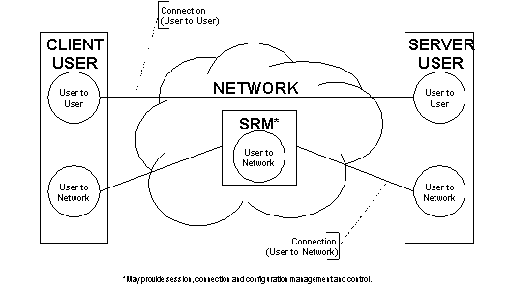
Figure 1: DSM-CC Functional Reference Model
Figure 1, from [1], shows connections for carriage of User-to-Network (U-N) information and User-to-User (U-U) information. A User-to-User information flow is used between Client and Server. The User-to-Network information flows between the Network and the Client or the Server. U-N messages are exchanged over U-N connections, their purpose is to control sessions and network resources (Sessions and Resources are discussed in the next section). Figure 1 shows the Network as containing a Session and Resource Manager (SRM) entity. The SRM is the entity that terminates the U-N connection from a User. An SRM could be distributed over a geographical area in order to cover the spread of a global network spanning many network providers. The User-to-Network part of DSM-CC defines a User-Network Interface protocol: it does not at the current time define any intra-network communication required.
The SRM can police Server/Client connections based on policies set at service subscription, it can be the point in the Network that provides configuration information to users, and it can authenticate the Clients.

2.1 U-N Messages
DSM-CC defines a standard message header for all U-N messages. The assumption is that these messages will be carried over some transport layer protocol. Minimum requirements are placed on any such protocol. It need not reliably deliver messages, but it must detect and discard corrupted messages. The transport service must be able to deliver entire U-N messages (i.e. lower layers perform any segmentation and re-assembly) but it need not be responsible for delivering messages in order. These requirements are met by common protocols such as UDP over IP and, indeed, by AAL5 over ATM.

2.2 U-U Connections
It is expected that there will be multiple U-U connections between a Client and a Server. In general the protocol carried over these connections is not specified by DSM-CC, it is a matter of agreement between the Client and the Server. However as elaborated upon in Section 7, DSM-CC does define a set of generic services that a Server may provide in an interoperable fashion to Clients. Invocation of these services is performed by a Remote Procedure Call (RPC) protocol carried over a U-U connection.
The following sections describe each of the different protocol areas that DSM-CC defines.

3. Network Session and Resource Control

3.1 Sessions
A key concept in DSM-CC is that of a session. A session is defined as an association between two Users, providing the capability to group together the resources needed for the instance of a service. Put another way, a Client accesses a service, say home shopping, by setting up a session with a Server. At the end of the service, when the Client no longer needs an association with the Server, the session is taken down. Figure 2 shows the DSM-CC U-N messages used for session setup.
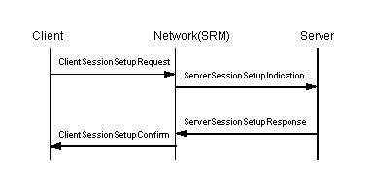
Figure 2: U-N Session Setup

3.2 Resources within Sessions
DSM-CC is intended to operate in an environment where network resources are not necessarily either free or bountiful. Rather it is assumed that resources will be acquired when needed to deliver a service, and released after a service has finished. Different services will require different resources. Resource allocation is tied to sessions. A Network-wide unique sessionId identifies a session in the network. All resources belonging to an instance of a service are tagged with the sessionId, and can thus be easily identified. This is useful for billing and administration by the Network, and for disposing of all resources associated with a session when the session is torn down. The DSM-CC session setup protocol is designed to allow client authentication by the Network, and to ensure that the client is aware that a session is set up, and thus accepts responsibility for it.
During a session the Server can request that the Network add to the session more resources (or remove existing resources), depending on the phase of the service. This is done with the AddResource message set (respectively, the DeleteResource message set). In these messages the Server describes the resources it needs from the network using Resource Descriptors.

3.3 Connections
Connections for User-to-User information flows are the main network resources that make up a session. A DSM-CC session will usually comprise more than one U-U connection. Often sessions are shown as having a control stream, for RPC messages, and an MPEG-2 stream. Sophisticated applications may use more connections, for example, a connection to carry video that is shown in a window whose surrounding background is sent over another high speed connection. It should also be noted that the Server end of connections within a session do not all need to terminate at the same Network Service Access Point (NSAP): a Client may be receiving information from more than one source within a given session. This is one of several aspects in which the DSM-CC concept of a session differs from that of a multi-connection call as it is defined in Q.298x [6].
DSM-CC allows the separation of session and resource management from network connection control protocols. A Network may use the DSM-CC session and resource management protocol but implement connection control using the protocols of the underlying transport network(s). For example, in an ATM environment, connection control is performed using Q.2931, the standard connection control protocol for ATM Switched Virtual Connections (SVCís) [7]. ATM can be integrated into a DSM-CC network in such a way that the Users (Client and Server) use Q.2931 directly. A more in depth description of the use of DSM-CC with Q.2931 is provided in [8], and in an informative annex of DSM-CC.

3.4 Building connections out of network resources
A Network resource is any minimally allocatable transport capability. For some networks this is an end-to-end connection and resources are directly equatable with connections. However DSM-CC is set up to deal with multi-resource connections. A connection is a grouping of one or more network resources that provides the capability to transfer information between two or more end points. For example, in the case when a non-ATM Hybrid Fiber Coax (HFC) provides the access to the Client while Servers are connected to a core ATM network, a connection is composed of HFC non-ATM resources and of ATM resources. See Figure 3.
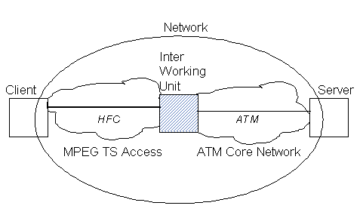
Figure 3: A connection through a Core ATM Network with an HFC Access Network
Resource Descriptors are data structures passed between Network and Users in resource allocation messages that describe resources. DSM-CC defines the format for many common types of network resources, for example ATM VCCís and MPEG transport streams. A Resource Descriptor contains attribute values appropriate to the type (e.g. source and destination addresses for ATM SVC, Program Map Table for MPEG TS). It also indicates whether attributes of the resource are negotiable and who initiates allocation of the resource (Client, Network or Server).
Resource Descriptors also contain Association Tags, which have end-to-end significance. All the resources that contribute to a connection have the same Association Tag. When there is a change in network technology, it is the SRM's responsibility to generate new Resource Descriptors for the Client view: A Server requests resources according to its view of the Network (ATM in the example in Figure 3), while the Client receives Resource Descriptors based upon its view (MPEG TS in the example in Figure 3). Even in an end-to-end ATM network, both Client and Server view Resource Descriptors are needed since the Client and Server each see a different VP/VCI field for the same connection. However, Resource Descriptors in both views will contain the same Association Tag. Each Resource Descriptor contains a flag indicating the view (Client or Server) that it belongs to. This ability to describe connections across multiple Network technologies is unique to DSM-CC.

3.5. User-User Notification using PassThru messages
DSM-CC sessions are always initiated by a Client. However, in some cases where DSM-CC is used, the Server (or another Client) must be able to notify a Client that it should now set up a DSM-CC session. For example, for telephony or video conferencing, DSM-CC U-N PassThruReceipt message can be used to indicate to a User that an incoming call requires the User to set up a DSM-CC session to receive it. If the PassThruReceipt message is unanswered, it can be inferred that the User it was sent to was not present or did not wish to receive the call.
Work within the ITU-T T.120 group uses U-N PassThruReceipt to indicate an incoming multimedia call.

4. Configuration of a Client
In a typical DSM-CC scenario, a Client (e.g. set top box) would, upon start-up, use the U-N Config message set to configure itself for the network that it finds itself attached to.
U-N Configuration can be initiated by the User (messages UNConfigRequest, UNConfigConfirm), or by the Network (UNConfigIndication, UNConfigResponse), or as consequence of a User listening to a well-known broadcast channel (UNConfigIndication).
After a U-N Config message sequence, the Client is aware of network specific parameters such as how sessionIds are allocated, how to communicate with the SRM (e.g., which VP/VCI, E.164 address, or IP address). The Client also receives a default service location.
The U-N Configuration part of DSM-CC is an independent protocol area. Any User application that requires initial configuration from a Network could use this part of DSM-CC.

5. Downloading to a Client
The download protocol within DSM-CC is a lightweight and fast protocol for downloading data or software from a Server to a Client. When a Client sets up a session with a Server, DSM-CC allows, but does not require, the Server to download to the Client a complete operating environment (including Remote Procedure Call, or RPC, stacks).
In order to ensure that data downloaded to a user device will work on that device, user compatibility information may need to be sent to the Server performing the download before the download begins. DSM-CC provides generic user compatibility descriptors that allow a device to describe itself to the Server.
A complete download operation transfers a download "Image" to a Client. The image is sub-divided into one or more "Modules", which are further divided into "Blocks". The "Block" size is negotiated to meet requirements for efficiency and effective error detection, and takes into account the transport mechanism being used.
What is unique about the DSM-CC Download protocol is that it supports both a traditional (interactive) flow-controlled download, as well as a non-flow-controlled (broadcast) download. Download control messages may be used to exchange information about the download process prior to the actual data transfer.
Download data messages are used to transport the data being downloaded, and for interactive download, to acknowledge the transmission of the modules. A Server can use the broadcast case to download data to several Clients simultaneously. In this case compatibility descriptors within the download info message direct the client to the specific channel broadcasting at a compatible rate.
With broadcast data carousels in mind, DSM-CC ensures that enough information is present in a Download control message to enable a Client to start receiving data out of sequence. For example, it allows a Client to start receiving data as soon as it tunes to a download channel, even if a download is already underway.
The ability to download software to the Client means an elimination of any costs associated with version control or periodic updates to the Client resident software. This is ideal for low-cost Client devices (e.g. set top boxes), and simplifies maintenance procedures for service providers.

6. VCR-like control of the video stream
The MPEG-2 standard for video encoding/decoding does not address the issue of play times for the video. MPEG-2 streams include their own internal clock times in the encoded streams that relate the encoded video to the encoded audio to allow the synchronization of the two. However, video playback requires more than this: To support random positioning within a stream and a variety of play rates, the DSM-CC media stream interfaces make use of a temporal addressing scheme created for DSM-CC, called Normal Play Time (NPT). NPT is the "clock" a viewer associates with a "program". NPT advances normally when in normal play mode, advances quickly when a user selects fast forward for a stream, or decrements quickly when rewind is selected. As well, DSM-CC has introduced the concept of a stream state machine. Figure 4, adapted from [1], shows transitions for a basic stream state machine, using just the Stream resume() and pause() methods.
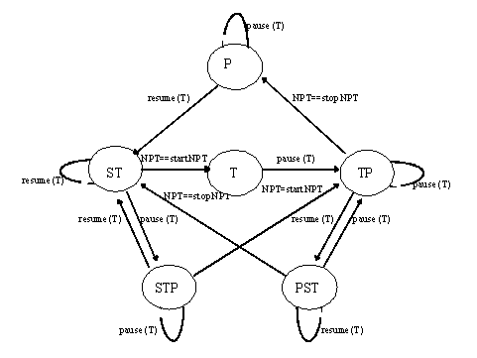
Legend
P | Pause | There is one phase. The Server is not transporting the media stream.
ST | Search Transport | There are two phases with one time value to describe the transition. The Server is searching for start NPT. When at start NPT, it will transport the media stream. Since there is no rStop, the Server will continue to advance the stream and pause at End of Stream.
T | Transport | The Server is transporting the media stream and will pause at End of Stream.
TP | Transport Pause | The Server is transporting the media steam and will pause at stop NPT.
STP | Search Transport Pause | There are three phases with two time values to describe the transitions. The Server is searching for start NPT. When at start NPT, it will transport the media stream until stop NPT.
PST | Pause Search Transport | There are three phases with two time values to describe the transitions. The Server is transporting the media stream. It will transport the media stream until stop NPT, then it will search to start NPT and transport the media stream.
Figure 4: Basic Stream State Machine Transitions

7. Generic Interactive Application Services

7.1 U-U Interfaces
The DSM-CC User-to-User part provides a generic set Multimedia User-to-User interfaces. These interfaces provide modular building blocks that can be used to enable a wide range of multimedia applications, from movies on demand, to teleshopping, to games and distance learning.
Interface definitions are written in the Interface Definition Language (IDL) [9] and provide two distinct interfaces (see Figure 5): an Application Portability Interface (API), defined for programmers writing applications that run on Clients, and a Service Interoperability Interface (SII), defined to allow Clients and Servers from different manufacturers to operate together. The IDL of the Service Interoperability Interface leads to a fixed bit pattern on the wire once the Remote Procedure Call (RPC) encoding scheme and message set have been chosen. DSM-CC does not specify which RPC scheme is used. However, its aim is to permit interoperability with CORBA 2.0, the Common Object Request Broker: Architecture and Specification, Revision 2.0 [10]. DAVIC has chosen CORBA 2.0 RPC (UNO - Universal Networked Objects) and encoding (CDR - Common Data Representation) for its specification of DSM-CC.
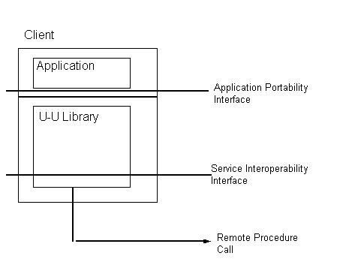
Figure 5: Application Portability and Service Interoperability Interfaces
While the DSM-CC U-U part can be used separately from the U-N part, DSM-CC describes how the DSM-CC U-U and U-N parts can be integrated to provide a working system model for a full DSM-CC system.
The DSM-CC U-U interfaces do not necessarily need to be the only ones at the Client or the Server. For example, other types of interfaces could also be downloaded which would allow hybrid applications such as simultaneous access to video conferencing and to multimedia databases.

7.2 Summary of U-U Interfaces
Figure 6, adapted from [1], summarizes the DSM-CC Core U-U interfaces. The Stream interface provides VCR-like control to the Client. The File interface allows a Client to read and write files stored on a Server, while the Directory interface provides navigational facilities. Lists of information can be processed by the Client using the BindingIterator interface. Session interfaces provide attachment to (and conversely detachment from) ServiceGateway services.
The abstract interfaces Base and Access provide interfaces common to more than one instantiable interface. The abstract interface First enables a Client to obtain its first objects.
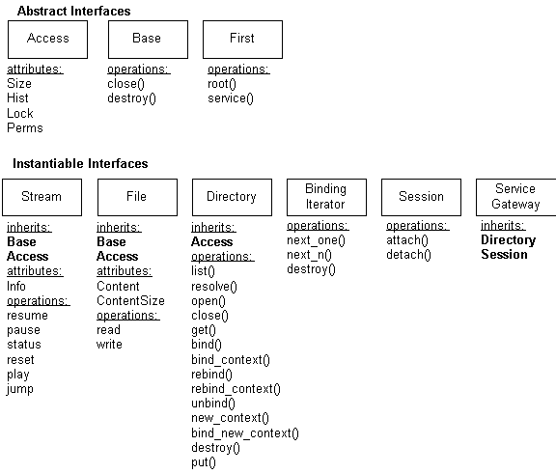
Figure 6: DSM Core Interfaces

8. Generic Broadband Application Services

8.1 Data Carousel and U-U Object Carousel
The Data Carousel protocol area makes use of non-flow-controlled download messages to provide periodic broadcast of data to a set of Clients. A download control message provides a list of available modules from a particular data carousel so that each Client can identify which modules it wishes to capture. Since for the data carousel case, no reverse channel from Client to Server is present, it is assumed that all data transfer parameters have been agreed upon a priori, and that the Client knows on which broadcast channel to start listening for download control and data messages.
While simple images may be distributed using the generic data carousel services, a more ambitious use of data carousel services is to provide an environment where the actual U-U objects behind user services are physically delivered to Clients. To support this, DSM-CC specifies a U-U Object Carousel and a Broadcast Interoperability Protocol (BIOP). BIOP provides a standard way of embedding in broadcast carousels object references that describe actual locations of object representations within the same broadcast channel.
The types of U-U objects currently supported are Name Space, File and Stream, thus allowing a Client to use the U-U object carousel to identify streams the Client wishes to view. BIOP is compatible with the RPC protocol so that a particular application may mix both broadcast and interactive service components.

8.2 Switched Digital Broadcast Channel Change
A popular service for broadband networks is the delivery of digital broadcast programs (e.g. digital TV, near video on demand). In some types of broadband networks, such as Fiber to the Curb (FTTC), the economics of network design favor the delivery of digital broadcast programs to InterWorking Units (IWUís) within a delivery system and from there multicasting programs to Clients. Although an entire range of broadcast programs is available at the IWU, it is not practical in these types of networks to simultaneously deliver all digital broadcast programs to each Client. Each Client is typically sent one or a few programs at a time. When a Client wishes to switch from channel to channel, then the IWU must be signaled for a change of channel connection.
The Switched Digital Broadcast (SDB) Channel Change Protocol specifies a protocol specifically for this application. The SDB Channel Change Protocol is exchanged between a Client and between an InterWorking Unit (IWU) in the Network. The SDB Channel Change Protocol forms a separate protocol area within DSM-CC and may be used independently from the rest of DSM-CC. In particular, SDB Channel Change protocol messages have been designed to fit into an ATM AAL5 cell. Figure 7 shows a simplified version of the SDB architecture. For clarity, this figure has left out the SDB Management Server, and the lines signifying session establishment between it and the SRM, and between the SRM and the Client. See [2] for more detail.
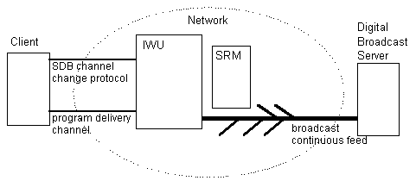
Figure 7: Switched Digital Broadcast (SDB) Architecture
An earlier section describes how network resources are aggregated into simple point-to-point connections. When DSM-CC is used for Switched Digital Broadcast (SDB) services, we have an example of a more complex grouping of resources. From (Digital Broadcast) Server to Network there are broadcast continuous feed resources containing multiple programs, while the resources between Client and Network implement a channel changing connection and a connection for the delivery of a single program's content. Each resource is linked to its correct interface using the DSM-CC Association Tag described in an earlier section.

9. Using DSM-CC for Video on Demand
A typical scenario using DSM-CC would be for video on demand. Upon start-up, a Client (e.g. set top box), would initiate U-N Config to configure itself using information stored in the Network. U-N Session Setup is then used to set up a session between the Client and the Server through the Network. Then, based on context information received by the Client in the U-U Session attach message, connections for download are set up. Download is invoked to retrieve the appropriate Client software. Using the U-U Directory functions, a navigator application would provide a menu of options to the user. Once a selection is made, U-U Download may again be used for the Client to acquire necessary code corresponding to the menu choice. For a video selection, U-N AddResource messages are used to set up new connections for the video and audio streams. U-U Stream Manipulation functions are then available to the user.

10. Conclusion
DSM-CC is a collection of protocol areas for the delivery of multimedia services over broadband networks. DSM-CC defines a protocol for User-to-Network messages to realize Session and Resource management. It provides protocols for both Client Configuration and Download. DSM-CC includes an interface for VCR-like control of video streams, and interfaces for a multitude of other generic interactive application services. As well, through the definition of a Data Carousel and a U-U Object Carousel, DSM-CC provides protocols for generic broadband application services. For channel changing in broadcast networks, DSM-CC includes a protocol for Switched Digital Channel Change.
With its Configuration and Download capabilities, DSM-CC is ideal for low-cost Client devices such as set top boxes. Using DSM-CC, a Client is always configured with the latest information from the Network, and receives downloads of the latest software from the Server. Thus, any costs associated with version control or incompatible versions are eliminated.
DSM-CC is widely applicable. It is based upon a very general model of Client, Server and Network entities. It does not dictate how each entity must be realized (although it provides some example ñ informative ñ organizations). Rather the DSM-CC specification focuses on the User-to-Network Interfaces and the User-to-User Interfaces.
DSM-CC is very flexible. A network supporting DSM-CC can offer a wide range of broadband applications. Each protocol area can be implemented separately thus aiding in the integration of the DSM-CC standard with other standards e.g., Direct Video Broadcast (DVB) makes use of a subset of DSM-CC U-N and U-U messages, but not the rest of DSM-CC [11]. Similarly the DSM-CC Switched Digital Broadcast (SDB) Channel Change Protocol can be implemented without implementing the DSM-CC U-N or U-U messages.

11. References
[1] Information Technology - Generic Coding of Moving Pictures and Associated Audio: Digital Storage Media Command and Control - ISO/IEC 13818-6 International Standard, ISO/IEC JTC1/SC29/WG11 MPEG96/N1300p1, July, 1996.
[2] Information Technology - Generic Coding of Moving Pictures and Associated Audio: Systems - ITU-T Recommendation H.222.0/ ISO/IEC 13818-1 International Standard, ISO/IEC JTC1/SC29/WG11 N0801rev, Apr. 1995.
[3] Digital Audio-Visual Council, DAVIC 1.0 Specification, Dec. 1995.
[4] Digital Audio-Visual Council, DAVIC 1.1 Specification, Dec. 1996.
[5] D. Minoli "Video Dialtone Technology" McGraw-Hill (New York) 1996.
[6] ITU-T Draft Recommendation Q.298x - DSS 2 signaling to support multiconnections per call, will not be approved before 1997.
[7] ITU-T Recommendation Q.2931 - 1995 - Broadband Integrated Services Digital Network (B-ISDN); Digital Subscriber Signaling System No. 2 (DSS 2); User-Network Interface (UNI) Layer 3 Specification for Basic Call/Connection Control.
[8] V. Balabanian, L. Casey, N. Greene, Digital Storage of Media-Command and Control Protocol Applied to ATM, IEEE Journal of Selected Areas of Communications, Vol. 14, No. 6, Aug. 1996.
[9] ISO/IEC 14750 Object Management Group Interface Definition Language (OMG IDL)
[10] CORBA 2.0 The Common Object Request Broker: Architecture and Specification, Revision 2.0, Object Management Group (OMG), July, 1995.
[11] DVB TM1594, Digital Video Broadcast Draft Specification for Network Independent Protocols for Interactive Services, March, 1996.

